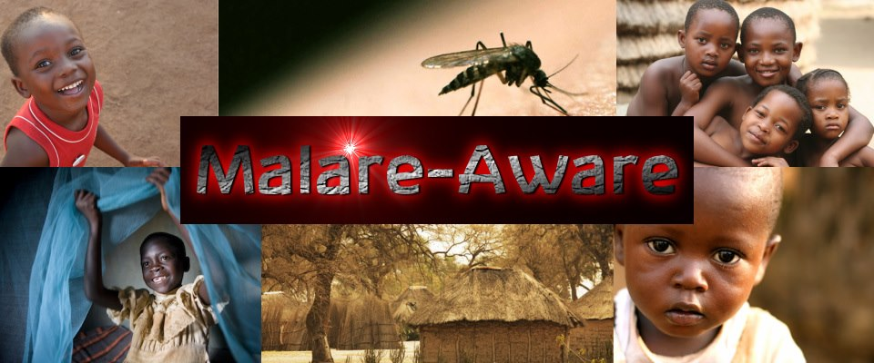
Team Members:
Kelly Keane
Jake Johnson
Casey Maffucci
Victoria Begley
Emily Rogalin
Mike Ranilla

Table of contents:

- Project overview
- Introduction
- Project goals and objectives
- Methodology
- Resources
- Team organization structure
- Timeline
- Appendices

Project overview:

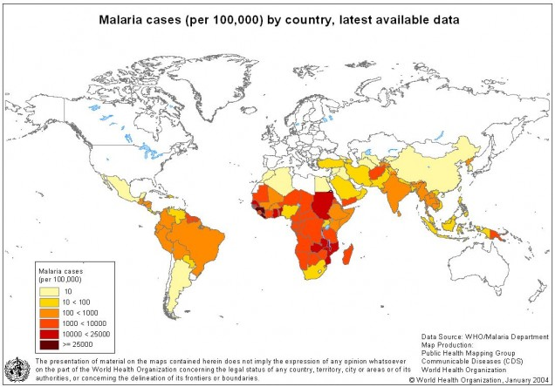
Malaria is one of the biggest killer diseases the world has ever known. It affects over 200 million people in over 50 countries every year. Although it is found in all hemispheres, the area that suffers the most from Malaria are African countries – 91% of the reported cases of Malaria occur in Africa.

Victims of malaria experience a wide range of symptoms ranging from sever fever, body aches, chills, nausea, to enlarged spleen, enlarged kidney, and jaundice. As a result of this, adults are kept out of the work force and children are kept out of schools. Tourism of malaria-infected areas also suffers, bringing down the economy of these countries.
The disease itself is caused by the parasite Plasmodium, specifically Plasmodium falciparum, Plasmodium vivax, Plasmodium ovale and Plasmodium malariae. All of these species cause Malaria, Plasmodium Falciparum is the most likely to cause death. The vector of this parasite is the female Anopheles mosquito, which transmits plasmodium to humans through a bite. When the parasite enters the blood stream it goes straight to the victims liver, where it begins reproducing. It then enters the bloodstream and continues reproducing. These Red Blood Cells that become infected burst, depleting the body of oxygen and harming the victim.

What can be done to combat this disease? Using the fungus Metarhizium Anisopliae, we can stop the spread of malaria. This naturally grown fungus can be genetically modified with two chemicals to produce proteins that attack malaria. The first is the protein SM1. This protein prevents the malaria parasite, Plasmodium, from attaching to the Anopheles mosquitos' salivary glands. Therefore, the parasite is not able to travel to the mosquito’s’ mouth parts where it bites people. The second chemical used is scorpine, found in the empire scorpion. This kills bacteria and the Plasmodium parasite. Studies have shown that this combination of chemicals has reduced the number of parasites present in the mosquito by 98%.
Our team, Malare-Aware, is lead by Kelly Keane, Emily Rogalin, Casey Maffucci, Victoria Begley, Jake Johnson and Michael Ranilla. We propose to use the genetically modified fungus in a spray form, as well as incorporating it into other house hold items in order to help fight the spread of malaria. By using our products, people will be killing off the malaria disease and therefore preventing the spread of malaria in the future.
The duration of our project includes thirteen months for the development and testing of our products, and an additional twelve months for distribution. Our project will also continue to exist indefinitely on our website, which serves as a resource for people looking to educate themselves on the effects of malaria or those who wish to donate to our cause.

Introduction:

Malaria is considered to be one of the world’s most dangerous infectious diseases. Malaria is a mosquito-borne infection caused by Plasmodium, a parasite that dwells within the system of the female Anopheles mosquito, and is transmitted from host to host by the bite of said mosquito.
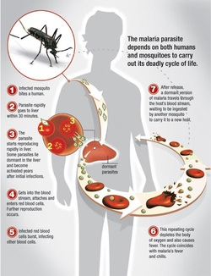
Its reach is global, affecting 103 nations, and every continent except Antarctica. An initial infection may take several weeks for symptoms to develop, and there is no cure despite nearly 30 years of a global effort to eliminate the illness. These efforts include many world organizations, scientific groups, and nations all together to find a cure. To date, there are 3.3 billion people at risk for malaria, and it is among the largest killers of children in the world.
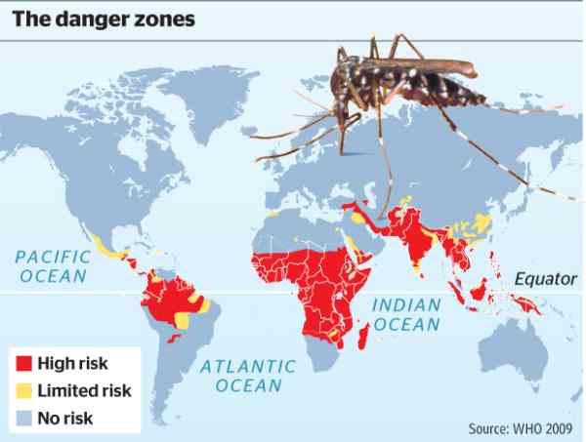

The United Nations considers malaria to be a major economic hindrance on a nation, further stopping the treatment of the disease. In 2010, between 600,000 and 1.2 million people died of Malaria, but with many deaths going unreported the actual number is believed to be much higher. Many world organizations are distributing malaria nets, pills, clean water, and teaching people how to better avoid the illness altogether. But many believe this is not enough. The cases of malaria each year continue to grow. That’s where we come in.

Project Goals and Objectives:

The goal of our project is to exterminate the disease of Malaria from the Anopheles mosquito without harming the population. The objective of this project is assisting in halting the extremely high death rate of Malaria in people all over the world. Our group is planning on infusing mosquito nets with the fungus Metarhizium anisopliaea as well as putting it in a spray to eradicate malaria. We will be designing an experiment on researching the most effective ratio of fungus to oil to water in the spray our project entails. The resources necessary to put our project plan completely into effect are the Metarhizium anisopliaea and the spray components of mainly water and oil. Our experiment can easily demonstrate success based on whether or not the fungus spray eradicates Plasmodium malariae, the Malaria causing parasite. Our project uses bio utilization through the use of the fungus and parasite, and is a very responsible project as well because our spray does not harm the Anopheles mosquito, only the Plasmodium parasite, and is safe to humans as well.
We are Malare-aware, and we’re here to help. Our remarkably simple solution to all this is a very simple bio utilization process. Currently, malaria nets are being issued and distributed in mass in high risk areas for malaria. These nets are made of a very fine mesh, small enough to prevent any would-be malaria transmitters from passing through. The malaria nets, however, do not eliminate the issue totally. They simply block the transmitter, allowing it to fly away to infect another host. This can be fixed, and without harm to humans. This is thanks to a particular genetically modified fungus, known as Metarhizium anisopliae. It is a naturally occurring fungus found in the soil all around the word that causes illness in insects by acting as a parasite onto its host. It does not infect humans, and therefore is considered to be safe as an insecticide. By using this fungus, we hope to use the spores in a spray, as to treat malaria nets and bedding. When an insect contacts the net, the spores cling onto it and by means of asexual reproduction will take over and eventually kill the host. The transport for such a spray could be something as simple as a bathroom spray bottle, something akin to a window cleaning solutions top. With this in mind, it creates a cost-effective, simple method of distribution throughout at risk areas, suppressing malaria. Besides a spray bottle, we hope to research and create laundry detergent and air diffusers to further prevent malaria.

Methodology:
Our main objective that we hope to complete as a group is to eradicate the Plasmodium malariae parasite from the Anopheles mosquito so as to not kill the organism itself but to only combat the spread of Malaria. Our project aims to save innumerable lives from the end of the leading killer of children. Our project would take approximately 25 months in total. 5 months of planning our ideas out, which 3 of those have already been utilized. Initial planning and obtaining our materials, including our fungus and units of dispersal would also take approximately 5 months. The development of spay for treatment would take about 4 months while testing to see which solution would be best. For 6 months we would have our testing phase, to test for the effectiveness of our product. Planning distribution would take around 3 months and finally distributing would take around 12 months.

Resources:
- Many spray bottles
- Metarhizium anisopliae fungus
- High tech Laboratory to be able to genetically modify the fungus in (plus professionals)
- Scorpine and SM1 chemicals in scorpion venom to genetically modify
- Suneem oil
- Malaria nets
- Some form of plasmodium, or anopheles mosquitos

Team Organization Structure:

Student name | Background information | Their job
Victoria Begley | Junior at Shelton High School. | Webmaster. Updates our blog and website. Researches for the website. One of our head speakers as well.
Casey Maffucci | Junior at Shelton High School | Created our PowerPoint presentation and researches for information on the PowerPoint.
Kelly Keane | Junior at Shelton High School | Helped set up Website and also wrote and put together information in our proposal.
Jake Johnson | Junior at Shelton High School | Helped write up the proposal and researches for the website and proposal.
Emily Rogalin | Junior at Shelton High School | Created our PowerPoint along with Casey and also researches for more information on our PowerPoint.
Michael Ranilla | Senior at Foran High School | Helped research and write up the proposal and also is our second speaker.

Our advisors are our Biotechnology teacher, Mrs. Ebmeyer and Jordan Kovacs, a senior at Shelton High School who attended Expo last year on team Xyleflow AND .

Timeline:
Project planning: 5 months
Initial planning, procurement of materials, including Metarhizium anisopliae, units for dispersal, mosquito nets and other malaria protective devices: 5 months
Development of spray for treatment of nets: 4 months
Testing phase, to ensure effectiveness of product: 6 months
Planning of distribution: 3 months
Distribution: 12 months
Total time: 25 months

Appendices:
http://www.npr.org/2011/02/25/134031191/fungus-knocks-out-malaria-in-mosquitoes
http://www.youtube.com/watch?v=QwEkGCjbbJ8
http://www.youtube.com/watch?v=IVbq2yQH52g
http://www.youtube.com/watch?v=OkfHy6gdAbM
http://globalhealthsciences.ucsf.edu/global-health-group/malaria-elimination-initiative
Source of calculations, non-germination: http://www.drrajanlaboratories.com/product8.html
http://www.entomology.wisc.edu/mbcn/kyf607.html
http://www.nih.gov/researchmatters/march2011/03072011malaria.htm
http://news.sciencemag.org/sciencenow/2011/02/a-fungal-vaccine-for-malaria-car.html
http://exploreable.wordpress.com/2011/04/22/science-primer-winning-the-war-on-malaria/
http://www.cdc.gov/MALARIA/
http://www.bu.edu/themovement/2010/10/14/the-new-drug-war-against-malaria/

